# CS 255 System Design Document Template

This template lays out all the different sections that you need to complete for Project Two. Each section has guidance to prompt your thinking. You will need to continually reference the interview transcript as you work to make sure that you are addressing your client’s needs. There is no required length for the final document. Instead the goal is to complete each section based on what your client’s needs are. Remove this note when you are finished, and replace all bracketed text with the relevant information.

## UML Diagrams

### UML Use Case Diagram

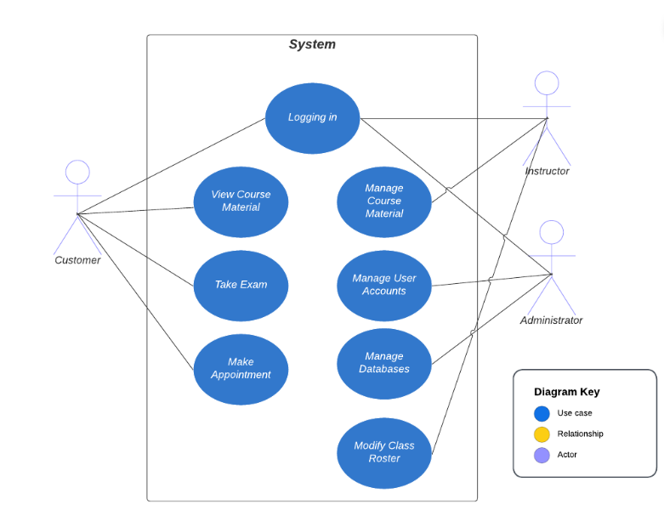

### UML Activity Diagrams

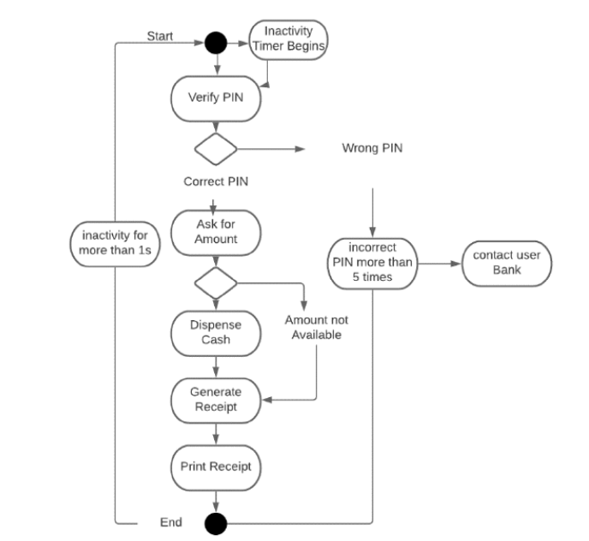

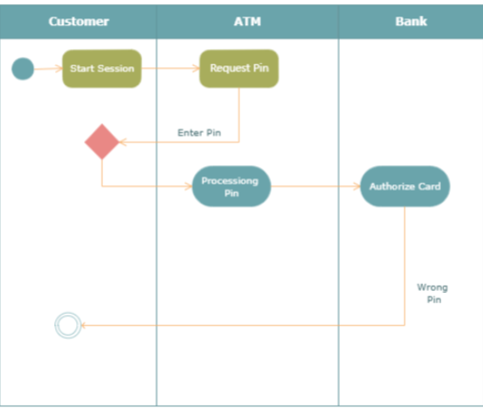

### UML Sequence Diagram

*[You were asked to create a sequence diagram based on* ***one*** *of the use cases you chose. Please insert your sequence diagram here. Check to make sure that you included appropriate components and symbols and that your design meets the client’s needs.]*

### UML Class Diagram

*[You were asked to create a class diagram based on the different classes and attributes needed for your system design. You are* ***not*** *required to include methods, but you may if you wish. Please insert your class diagram here. Check to make sure that you included appropriate components and symbols and that your design meets the client’s requirements.]*

## Technical Requirements

*[Based on the diagrams you have created, describe the technical requirements of your system. These requirements should address the required hardware, software, tools, and infrastructure necessary for your system design.]*

The system must be capable of functioning in a web-based setting, ideally via the cloud. The system should operate rapidly to prevent the creation of duplicate appointments and to allow users to view the appointments and drivers that are available in real time. Additionally, they must receive their test results as away once the test has ended. The system has to be updated often. DriverPass wants to have the option to customize their driving packages, which will require a future update. They also need to keep current with DMV compliance, so if anything changes, they will need to update right away to be compliant.

In order to utilize the platform, the user will have to set up 2 factor authentication and submit a username and password that are case sensitive. By using HTTPS, encrypting the data before transferring it to the server, and regularly checking for security system upgrades, we can guarantee a safe connection. The account is restricted for 30 minutes and an alert is issued to the student and administrator if the user enters their password incorrectly five times. This will aid in "brute force" hacking efforts since it slows down their capacity to access accounts and notifies an admin if there are repeated unsuccessful attempts. Additionally, the two-factor authentication will help prevent unauthorized access.

The system must enable the learner to take a knowledge exam for driving. The system must allow the learner to schedule a driving lesson with a teacher. The technology must enable staff to schedule driving times for pupils. The system must enable the administrator to terminate personnel. The system will display the student's completed tests. The technology must enable the driver to leave the pupil driving comments or notes.